**Curriculum vitae**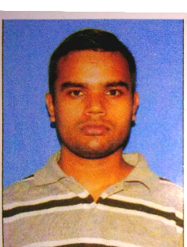

Name: - Shubankar Nath

Mobile No: - 9362922883

WhatsApp No.: - 8638157757

Email id: - [tukun12041995@gmail.com](mailto:tukun12041995@gmail.com)

Address: - C/o Bimal Kanti Nath, DIC Colony, Tezu, P.O/P.S:- Tezu, Dist:-Lohit, State: - Arunachal Pradesh,

792001

**Objectives**: - Seeking a position where my knowledge can be shared and enriched, where I can apply my skills in the field and work for the development of the organization with full commitment, loyalty, sincerity and hard work.

**Area of interest:**

* Website designing
* Teaching Science
* And Mathematics

**Educational qualifications:-**

|  |  |  |  |  |  |
| --- | --- | --- | --- | --- | --- |
| Name of education | Year | Board | Institution | Year of passing | Marks obtained |
| Class 10 | 2010 | CBSE | Govt. Hr. Sec. School, Tezu | 2011 | 84% |
| Class 12 | 2012 | CBSE | Govt. Hr. Sec. School, Tezu | 2013 | 60.8% |
| B.Sc (BOTH) | 2013 | AUS | Cachar College, Silchar | 2017 | 68 % |
| B.Ed | 2018 | RGU | Denning College of Teachers Education, Tezu | 2020 | 77.4% |

**Experiences: -** I have 2 years and 2 months of teaching experience. Also I have 6 months experience in web designing.

**Hobbies: -** Fishing, Listening song, Gaming, Swimming etc.

**Personal profile:-**

Father’s Name : - Bimal Kanti Nath

Mother’s Name : - Shipra Nath

D.O.B : - 12/04/1995

Language known: - Bengali, Hindi, English.

Nationality : - Indian

Permanent address:- Vill- Bahadarpur, P.O- larshingpar, P.S- Udharbond, Dist.- Cachar, State- Assam

House no. : - N/A

**Declaration: -**

I hereby declare that the information, furnished above is true to the best of my knowledge and belief.

**Place: -TEZU SHUBANKAR NATH**